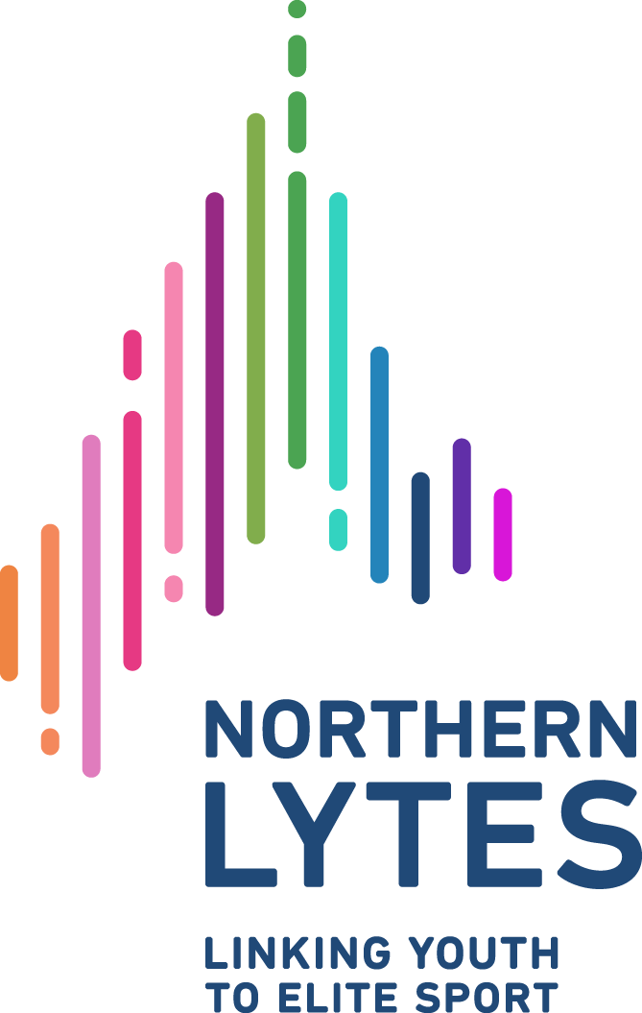

Northern LYTES Sport Promotion Grant

Background:

Initiated by Yukon Olympians Zach Bell and Emily Nishikawa, Northern LYTES provides opportunities for young athletes and coaches in the territory to access training from Canada’s Olympic / Paralympic athletes and professional coaches, by bringing those experts to the Yukon to work with Yukon programs in a sport camp setting.

In an effort to further develop Yukon athletes’ skills in promoting themselves and sport, as well as generate momentum for the Northern LYTES programing, Northern LYTES is excited to announce the Northern LYTES Sport Promotion Grant. 1-2 recipients will be awarded a grant of up to $1000 to offset the costs associated with individual education or athletics.

Grant applicants are asked to create a proposal geared towards spreading the word and driving applications for the Northern LYTES Programs. Successful grant recipients will be asked to carry out their promotions plan as well as complete a report detailing the impact of the grant.

The ultimate mission of the grant is to encourage and support young athletes in developing the skills they will ultimately use to promote themselves as athletes and individuals, while at the same time building an appetite within Yukon sport programs to engage with Northern LYTES initiatives.

Eligibility:
- Under 18 years old
- Yukon resident
- A member of a Sport Governing Body in good standing with Sport Yukon

Deadline for Application: June 30, 2020
Northern LYTES Sport Promotion Grant Application

Name:

Age:

Sport:

The funds are required to be used in a way that will help you move closer towards your goals or help you attain the next level in your sport. Please use the space below and tell us what the funds will be used for in as much detail as possible. Examples of (but not limited to) how the funds can be utilized:

- Attending a competition
- Attending a training camp
- Education costs of post secondary
- Other resources such as sport psychology, nutrition, strength and conditioning
- Equipment expenses

Please also provide detail on how this funding will impact you. How will this particular use of the funds take you closer to your goals or up your game? (eg. dates and location of competition or training camp, what type of equipment and the cost of it, etc)

Promotion Plan

What is your plan to promote Northern LYTES?
Your plan should include:

- Target audience (Who do you want to tell about Northern LYTES)
- At least 2 communications methods (i.e. direct outreach via calling or email, indirect via social media)
- Promotion duration (Start and end dates)
- Goals (i.e. generate a specific application for a camp, reach a certain number of people)
- Budget (optional) Will your promotion require a budget (i.e. materials or ads?)

Your plan should be creative and can focus on a specific approach (encouraging your own club to run a Northern LYTES camp) or more general (spreading a general message about the program through the Sport Yukon community). Please us the space below for your promotional plan.

Date: Signature:

